LAB

REPORT

CSE 114 : Data Structure and Algorithms Sessional

|  |  |
| --- | --- |
| PREPARED BY  Mehrin Farzana  ID: 2101013  Session: 2021-2022  Date: 22/09/2023 | SUPERVISED BY  Suman Saha  Lecturer  Department of IRE, BDU |

|  |  |
| --- | --- |
| logo1 | BANGABANDHU SHEIKH MUJIBUR RAHMAN DIGITAL UNIVERSITY  (BDU) |
|  |  |

**List of Problems**

1. Implement stack using array.
2. Evaluation of Postfix Expressions Using Stack.
3. C Program to Convert Infix to Postfix Expression using Stack.

**Problem No.:** 01

**Problem Statement:**

Implement stack using array.

**Code:**

#include<stdio.h>

#include<stdbool.h>

int top = -1;

int push(int *a, int n, int el){

if(top==n-1){

printf("Overflow!\n");

return -1;

}

a[++top]=el;

return 0;

}

int pop(int *a){

if(top==-1){

return -1;

}

top--;

return a[top+1];

}

int peek(int *a){

if(top==-1){

printf("Empty stack\n");

return -1;

}

return a[top];

}

bool isFull(int n){

if(top==n-1){

return true;

}

return false;

}

bool isEmpty(){

if(top==-1){

return true;

}

return false;

}

void display(int a[]){

printf("Your stack:\n");

for(int i=top; i>-1; i--){

printf("%d\n", a[i]);

}

}

int main(){

int n, top = -1, chc=1, el;

char c;

printf("Size of stack: ");

scanf("%d", &n);

int a[n];

while(chc){

printf("Menu:\n1. PUSH\n2. POP\n3. TopElement\n4. Display\nEnter your choice: ");

scanf("%d", &chc);

if(chc==1){

printf("Element to insert: ");

scanf("%d", &el);

push(a, n, el);

}

else if(chc==2){

int tmp = pop(a);

if(tmp!=-1){

printf("Popped element: %d\n", tmp);

}

else

printf("Underflow!\n");;

}

else if(chc==3){

printf("Top element: %d\n", peek(a));

}

else if(chc==4){

display(a);

}

printf("Do you wish to continue?(y/n) ");

scanf(" %c", &c);

if(c=='n')

chc=0;

}

return 0;

}

**Output:**

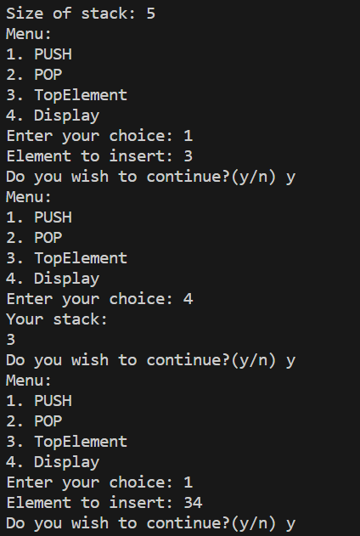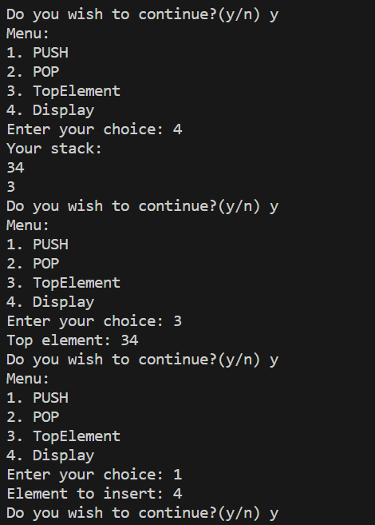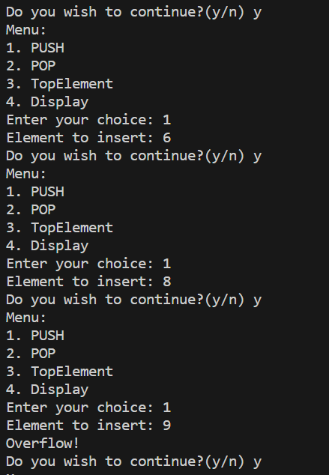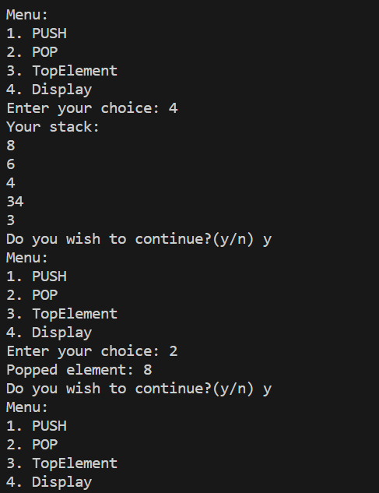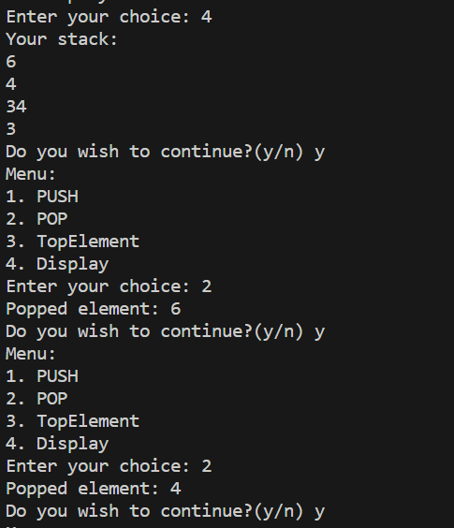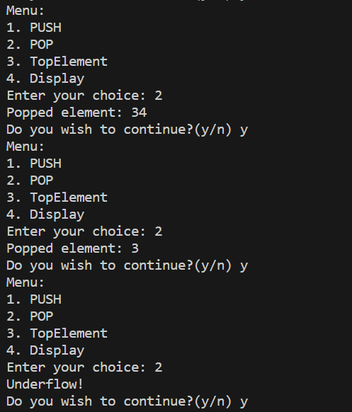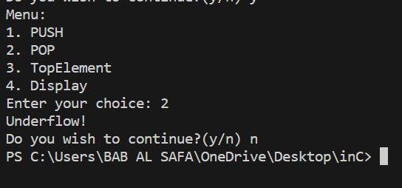

Fig 1.1: Output on console for case 1.

**Problem No.:** 02

**Problem Statement:**

Evaluation of Postfix Expressions Using Stack.

**Code:**

#include<stdio.h>

#include<stdbool.h>

#include<string.h>

int top = -1;

int push(int *a, int n, int el){

if(top==n-1){

printf("Overflow!\n");

return -1;

}

a[++top]=el;

return 0;

}

int pop(int *a){

if(top==-1){

return -1;

}

top--;

return a[top+1];

}

int peek(int *a){

if(top==-1){

printf("Empty stack\n");

return -1;

}

return a[top];

}

bool isFull(int n){

if(top==n-1){

return true;

}

return false;

}

bool isEmpty(){

if(top==-1){

return true;

}

return false;

}

void display(int a[]){

printf("Your stack:\n");

for(int i=top; i>-1; i--){

printf("%d\n", a[i]);

}

}

int char_to_int(char a[]){

int b[10],i,j,sum=0, mul=1;

for(i=strlen(a)-1; i>=0; i--){

b[i]=(a[i]-'0')*mul;

mul*=10;

}

for(j=0; j<strlen(a); j++){

sum+=b[j];

}

return sum;

}

int main(){

char c[101];

int a[101], op1, op2;

int num=0;

for(int i=0; ; i++){

scanf("%c", &c[i]);

if(c[i]=='\n') break;

if(c[i]!=' ' && c[i]!='+' && c[i]!='-' && c[i]!='*' && c[i]!='/' && c[i]!='^'){

num=(num*10)+(int)(c[i]-'0');

printf("%d\n", num);

}

else if(c[i]==' ' && c[i-1]!='+' && c[i-1]!='-' && c[i-1]!='*' && c[i-1]!='/' && c[i-1]!='^'){

push(a, 101, num);

num=0;

}

else if(c[i]=='+' || c[i]=='-' || c[i]=='*' || c[i]=='/' || c[i]=='^'){

op2=pop(a);

op1=pop(a);

if(c[i]=='+')

push(a, 101, op1+op2);

else if(c[i]=='-')

push(a, 101, op1-op2);

else if(c[i]=='*')

push(a, 101, op1*op2);

else if(c[i]=='/')

push(a, 101, op1/op2);

else if(c[i]=='^')

push(a, 101, op1^op2);

}

}

printf("%d\n", pop(a));

return 0;

}

**Output:**



Fig 1.1: Output on console for case 1.

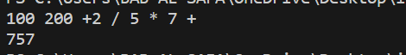

Fig 1.2: Output on console for case 2.



Fig 1.3: Output on console for case 3.



Fig 1.4: Output on console for case 4.

**Problem No.:** 03

**Problem Statement:**

C Program to Convert Infix to Postfix Expression using Stack.

**Code:**

// C code to convert infix to postfix expression

#include <stdio.h>

#include <stdlib.h>

#include <string.h>

#define MAX_EXPR_SIZE 100

int precedence(char operator)

{

switch (operator) {

case '+':

case '-':

return 1;

case '*':

case '/':

return 2;

case '^':

return 3;

default:

return -1;

}

}

int isOperator(char ch)

{

return (ch == '+' || ch == '-' || ch == '*' || ch == '/'

|| ch == '^');

}

char* infixToPostfix(char* infix)

{

int i, j;

int len = strlen(infix);

char* postfix = (char*)malloc(sizeof(char) * (len + 2));

char stack[MAX_EXPR_SIZE];

int top = -1;

for (i = 0, j = 0; i < len; i++) {

if (infix[i] == ' ' || infix[i] == '\t')

continue;

if (isalnum(infix[i])) {

postfix[j++] = infix[i];

}

else if (infix[i] == '(') {

stack[++top] = infix[i];

}

else if (infix[i] == ')') {

while (top > -1 && stack[top] != '(')

postfix[j++] = stack[top--];

if (top > -1 && stack[top] != '(')

return "Invalid Expression";

else

top--;

}

else if (isOperator(infix[i])) {

while (top > -1

&& precedence(stack[top])

>= precedence(infix[i]))

postfix[j++] = stack[top--];

stack[++top] = infix[i];

}

}

while (top > -1) {

if (stack[top] == '(') {

return "Invalid Expression";

}

postfix[j++] = stack[top--];

}

postfix[j] = '\0';

return postfix;

}

int main()

{

char infix[MAX_EXPR_SIZE];

scanf("%s", infix);

char* postfix = infixToPostfix(infix);

printf("%s\n", postfix);

free(postfix);

return 0;

}

**Output:**



Fig 1.1: Output on console for case 1.



Fig 1.2: Output on console for case 2.